Operating Systems Lab 1 – Dipesh Singh – 190905520

Question 1 : Write a program to print the lines of a file that contain a word given as the program argument.

Source Code :

#include<stdio.h>
#include<stdlib.h>
#include<string.h>
#include<unistd.h>
#include<fcntl.h>
#include<sys/stat.h>

int main(int argn, char *args[]){
int finp = open(args[2], O_RDONLY);
if(finp == -1){
printf("File not found, exiting...");
return 0;
}
char buffer[100], c;
int line = 0;
while(read(finp, &c, sizeof(c))>0){
if(c!='\n'){
strncat(buffer, &c, 1);
}
else{
line++;
if(strstr(buffer, args[1])!=NULL){
printf("%d : %s\n", line, buffer);
}
buffer[0]='\0';
}
}
close(finp);
return 0;
}

input.txt :

this is the test file
the keyword is ball
tennis ball
basketball
rugby
cricket ball

Output :

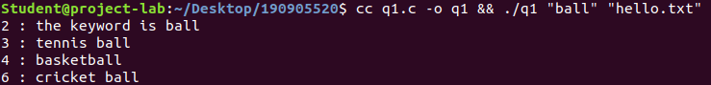
Question 2 : Write a program to list the files given as arguments, stopping every 20 lines until a key is hit.

Source Code :

#include <stdio.h>
#include <stdlib.h>
#include <unistd.h>
#include <sys/stat.h>
#include <fcntl.h>
#include <string.h>

int main(int argn, char *args[]){
if(argn<3){
printf("Please Enter Correct arguments");
return 0;
}
char files[100][100], line[100], c, temp;
int cnt = 0, lines;
for(int i = 1, j= 0; i< argn; i++, j++){
strcpy(files[j], args[i]);
printf("%s\n", files[j]);
}
for(int i = 0; i< argn -1 ; i++){
lines = 0;
int finp = open(files[i], O_RDONLY);
if(finp == -1){
printf("File not found, exiting ...");
return 0;
}
while(read(finp, &c, 1)!=0){
if(c !='\n') line[cnt++] = c;
else{
line[cnt] = '\0';
lines++;
cnt = 0;
if(lines == 20){
scanf("%c", &temp);
printf("---\n\n");
}
printf("Line %d: %s\n", lines, line);
}
}
close(finp);
}

return 0;
}

Output :

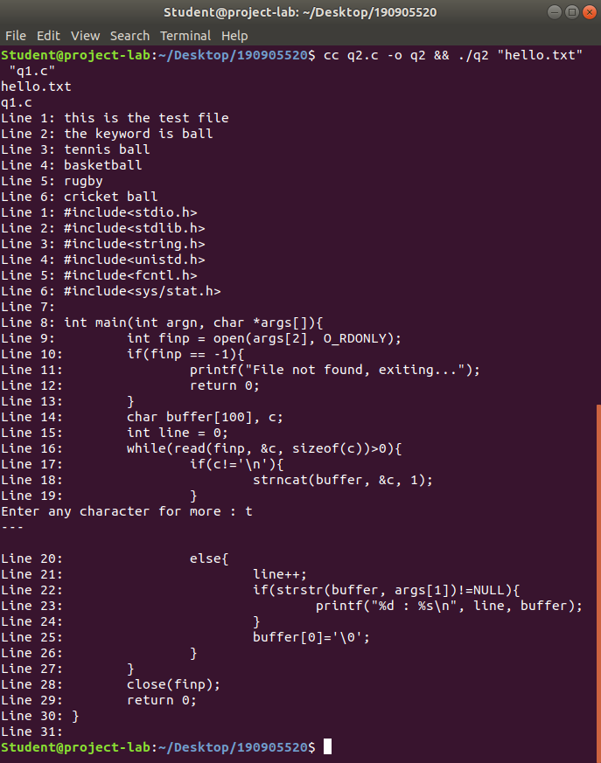

Question 3 : Demonstrate he use of different conversion specifiers and resulting output to allow the items to be printed.

Source Code :

#include<stdio.h>
#include<stdlib.h>
#include<sys/stat.h>
#include<unistd.h>
#include<fcntl.h>
#include<string.h>
#include<errno.h>

int main(int argn, char *args[]){
int integer_value = 45;
float float_value = 3.14;
char string_value[] = "Hello World";
char character_value = 'C';
printf("Integer = %d\nFloat = %f\nString = %s\nHexadecimal = %x\nExponential = %e\n", integer_value, float_value, string_value, integer_value, float_value );
errno = EPERM;
printf("Access Error : %m\n");
return 0;
}

Output :

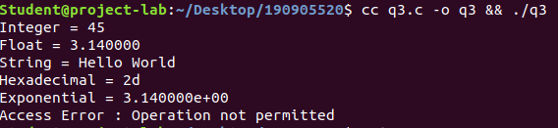
Question 4 : Write a program to copy character-by-character copy is accomplished using calls to the functions referenced in stdio.h.

Source Code :

#include<stdio.h>

int main(int argn, char* args[]){
FILE *finp = fopen(args[1], "r"), *fout = fopen(args[2], "w+");
if( finp ==NULL || fout == NULL ){
printf("FIle not found, exiting ... ");
return 0;
}
char c = 0;
while(c!=EOF){
c = fgetc(finp);
fputc(c, fout);
}
fclose(finp);
fclose(fout);
printf("Done\n");
return 0;
}

Output :

